Nitro-Tech Hardcore ™ Supplement Facts and Ingredients

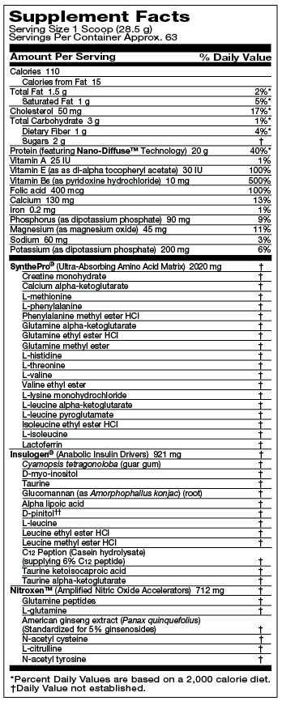
OTHER INGREDIENTS: PROTEIN BLEND (FEATURING NANO-DIFFUSETM WHEY PROTEIN CONCENTRATE [PROVIDING DI-, TRI-, OLIGO-, AND POLYPEPTIDES AND NANODIFFUSED PROTEIN], HYPER-PURE WHEY PROTEIN ISOLATE [ION-EXCHANGED 97% PURITY], PARTIALLY HYDROLYZED WHEY), COCOA POWDER, NATURAL AND ARTIFICIAL FLAVORS, MALTODEXTRIN, SOY LECITHIN, ASPARTAME, SALT, SILICON DIOXIDE, ACESULFAME-POTASSIUM. CONTAINS MILK INGREDIENTS. PHENYLKETONURICS: CONTAINS PHENYLALANINE.
DIRECTIONS: Add 1 to 2 servings (1 to 2 scoops) of Nitro-Tech® Hardcore to 4 to 8 oz. of cold water or skim milk and mix. For maximum results, consume 2 servings of Nitro-Tech Hardcore 3 times daily for a minimum of 6 weeks.
Note: To maintain product freshness, store in a cool, dry place. This product is sold by weight. Some settling may occur. Shake container before use.
WARNING: Taking this product without adequate fluid may cause it to swell and block your throat or esophagus and may cause choking. Do not take this product if you have difficulty in swallowing. If you experience chest pain, vomiting, or difficulty in swallowing or breathing after taking this product, seek immediate medical attention.

